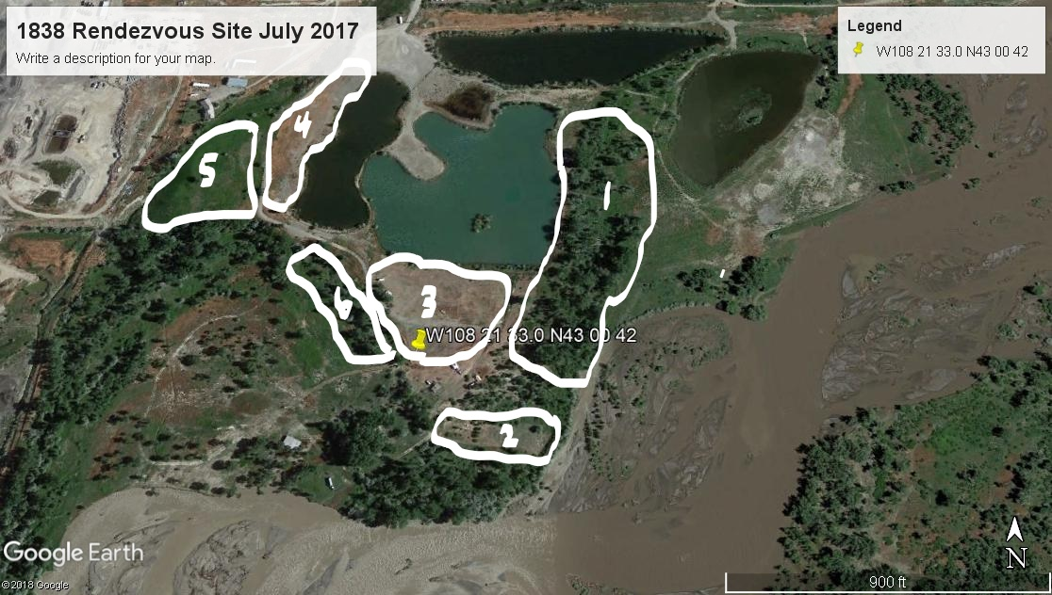
R
Possible High Water rendezvous layout…
1 – Primitive Area 5 – Tin Teepee area
2 – Shooting Range 6 – Archery/Hawk/Atl Atl area
3 – Trader’s Row R – The Roost (current Dobler shelter)
4 – Parking Area

